General: Parcel Lookups

The fields shown below may be used to help you quickly find the Parcel you are seeking, and are available throughout the Tax Administration application:

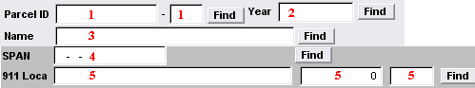

Select ONE of the following fields:

- Parcel ID: Enter partial Parcel ID and click “Find”. The “Lookup” window will appear. See page 2 for a view of the “Lookup” window and directions for its use.

- Year: Enter the Tax Year associated to the parcel you are looking up. You may click “Find” to select the year. The “Lookup” window will appear. See page 2 for a view of the “Lookup” window and directions for its use.

- Name: Enter partial Name and click “Find”. The “Lookup” window will appear. See page 2 for a view of the “Lookup” window and directions for its use.

- SPAN: Enter the SPAN Number for the parcel you are looking up. You may click “Find” to select the parcel by SPAN. The “Lookup” window will appear. See page 2 for a view of the “Lookup” window and directions for its use.

- 911 Loca: Enter the 911 address for the parcel you are looking up. You may click “Find” to select parcel by 911 address. The “Lookup” window will appear. See page 2 for a view of the “Lookup” window and directions for its use.

The “Lookup” Window
The Lookup window will appear when you have entered partial information (anything other than a full, valid and unique piece of Parcel information) as described above and clicked “Find.” The order in which this information appears will be based upon the field selected above.

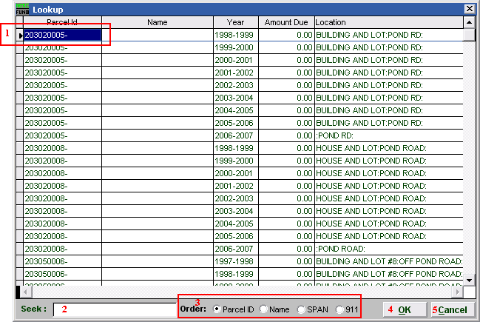
- You may click directly on the Parcel you are seeking and click “OK” to select it, OR you may use your arrow keys to move the highlighter to the Parcel you are seeking, and click “OK” (or hit Enter) to select.

- Seek: Enter partial account information associated with “Order” selected (see 2.), and the highlighter (1) will move to the most similar account. Click “OK” to select.

- Order: You may choose the order in which information will appear by clicking on the circle next to: “Parcel ID” to sort by Parcel ID, “Name” to sort alphabetically by last name, “SPAN” to sort by SPAN Number, “911” to sort by locatable address.

- OK: Click “OK” once you have selected the Parcel you want.

- Cancel: Click “Cancel” to return to the previous screen.

